|  |
| --- |
| Clemson University |
| MeTube  mmlab.cs.clemson.edu/spring14/g8/Metube/web |
| Team G8  Yaolin Zhang  Yan Bai  Yunqing Zhang |
|  |
|  |
| 04/29/2014 |

Contents

1. User Account 2

1.1 Registration 2

1.2 Sign-in 3

1.3 Profile update 3

1.4 Contact 4

1.5 Friend/foe/User Blocking 4

2. Data Sharing 4

2.1 Upload 4

2.2 Meta data input 5

2.3 Download/View 6

2.4 Media sharing/blocking 6

3. Media Organization 7

3.1 Browse by category 7

3.2 Channel 7

3.3 Playlists 8

3.4 Favorite Lists 8

3.5 Most viewed 8

3.6 Most recently uploaded 8

4. User interaction 9

4.1Messaging 9

4.2 Commenting 10

4.3 Media rating 10

4.4 Group discussion 11

5.Search 12

5.1Keywords-based search 12

5.2 Word cloud 12

5.3 Media recommendation 13

5.4 Feature-based media search 13

User Manual

# 1. User Account

Your account can be managed through functions in this module.

## 1.1 Registration

In the homepage(fig.1), you click ‘login’ button, then see the dialog window to register or login. If you don’t have the account, you should register one at first.

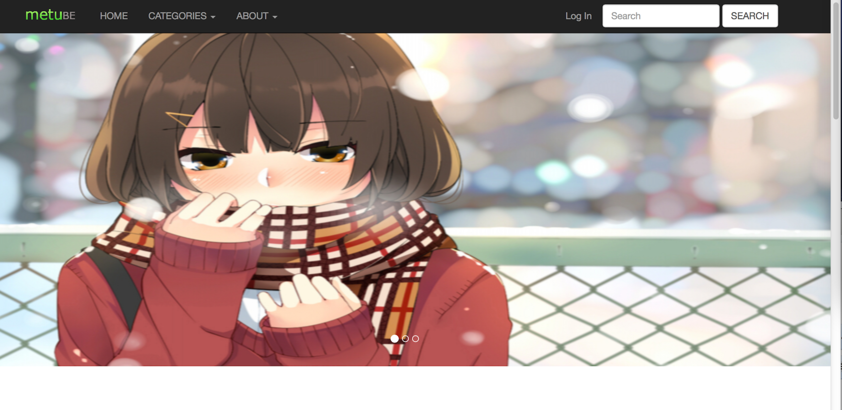

fig.1 homepage

Click ‘sign up’ button, you see the dialog window (fig.2),you fill up the form and click ‘sign up’ button then server sends you an email to activate your account.

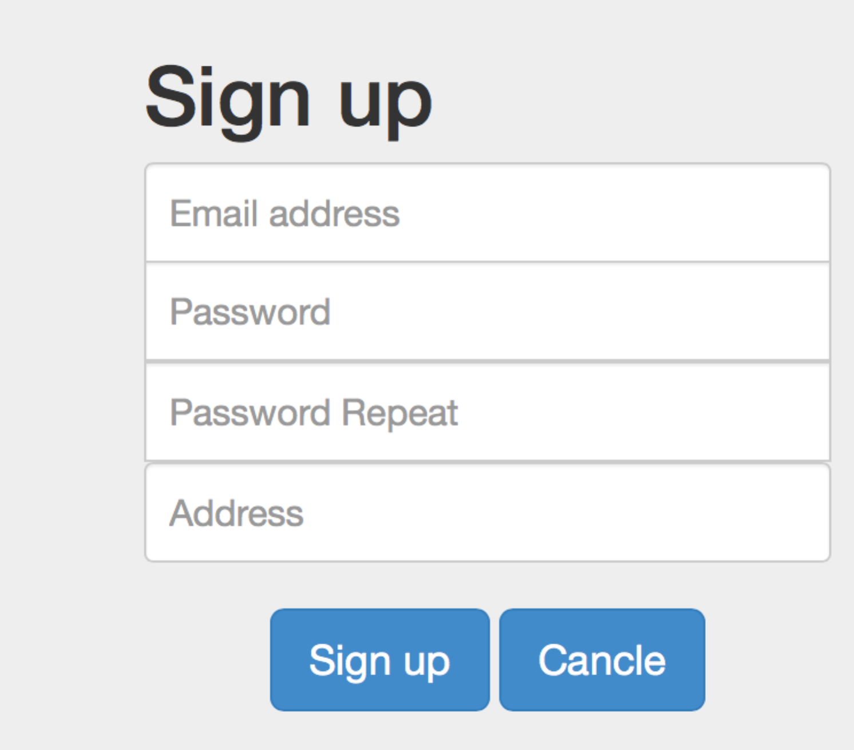

fig.2 sign up

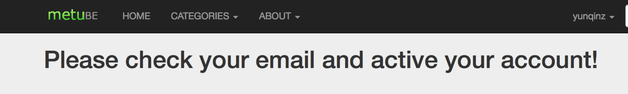

## 1.2 Sign-in

If you have already has a user account ,you can sign in directly. Input the username and password, you can sign in your account. Then the webpage refreshes to homepage. If you tick ’Remember me’, you can sign in your account automatically you visit this website next time.

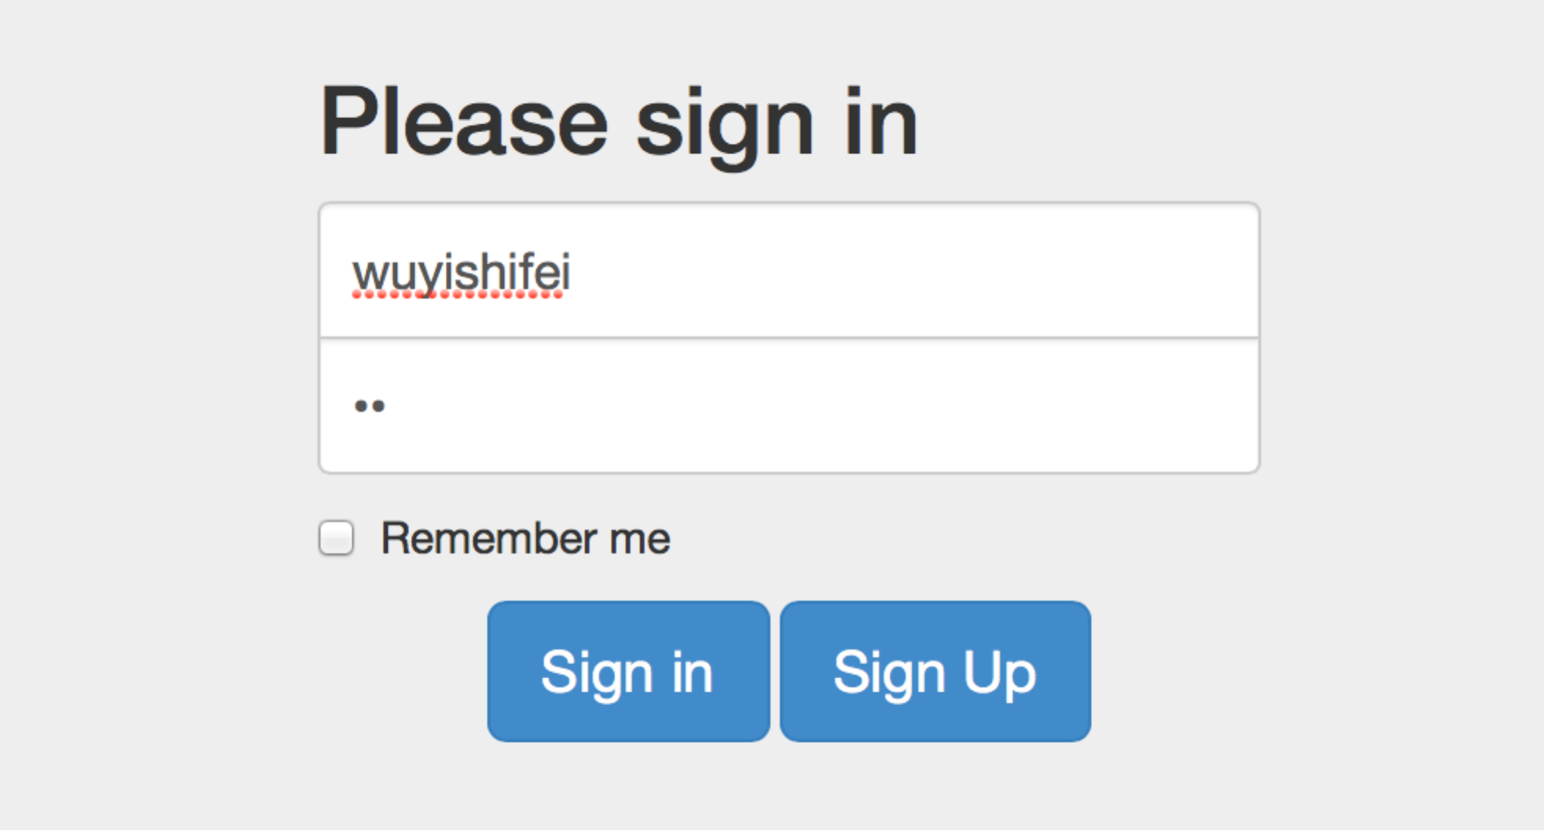

fig.3 sign in

## 1.3 Profile update

After signing in ,username displays in the navigation bar. Click yourname ,the user information displays in the window. Click ‘Account’ button, profile can be updated.

You can change the basic information listed below. Also you can change the photo and password.

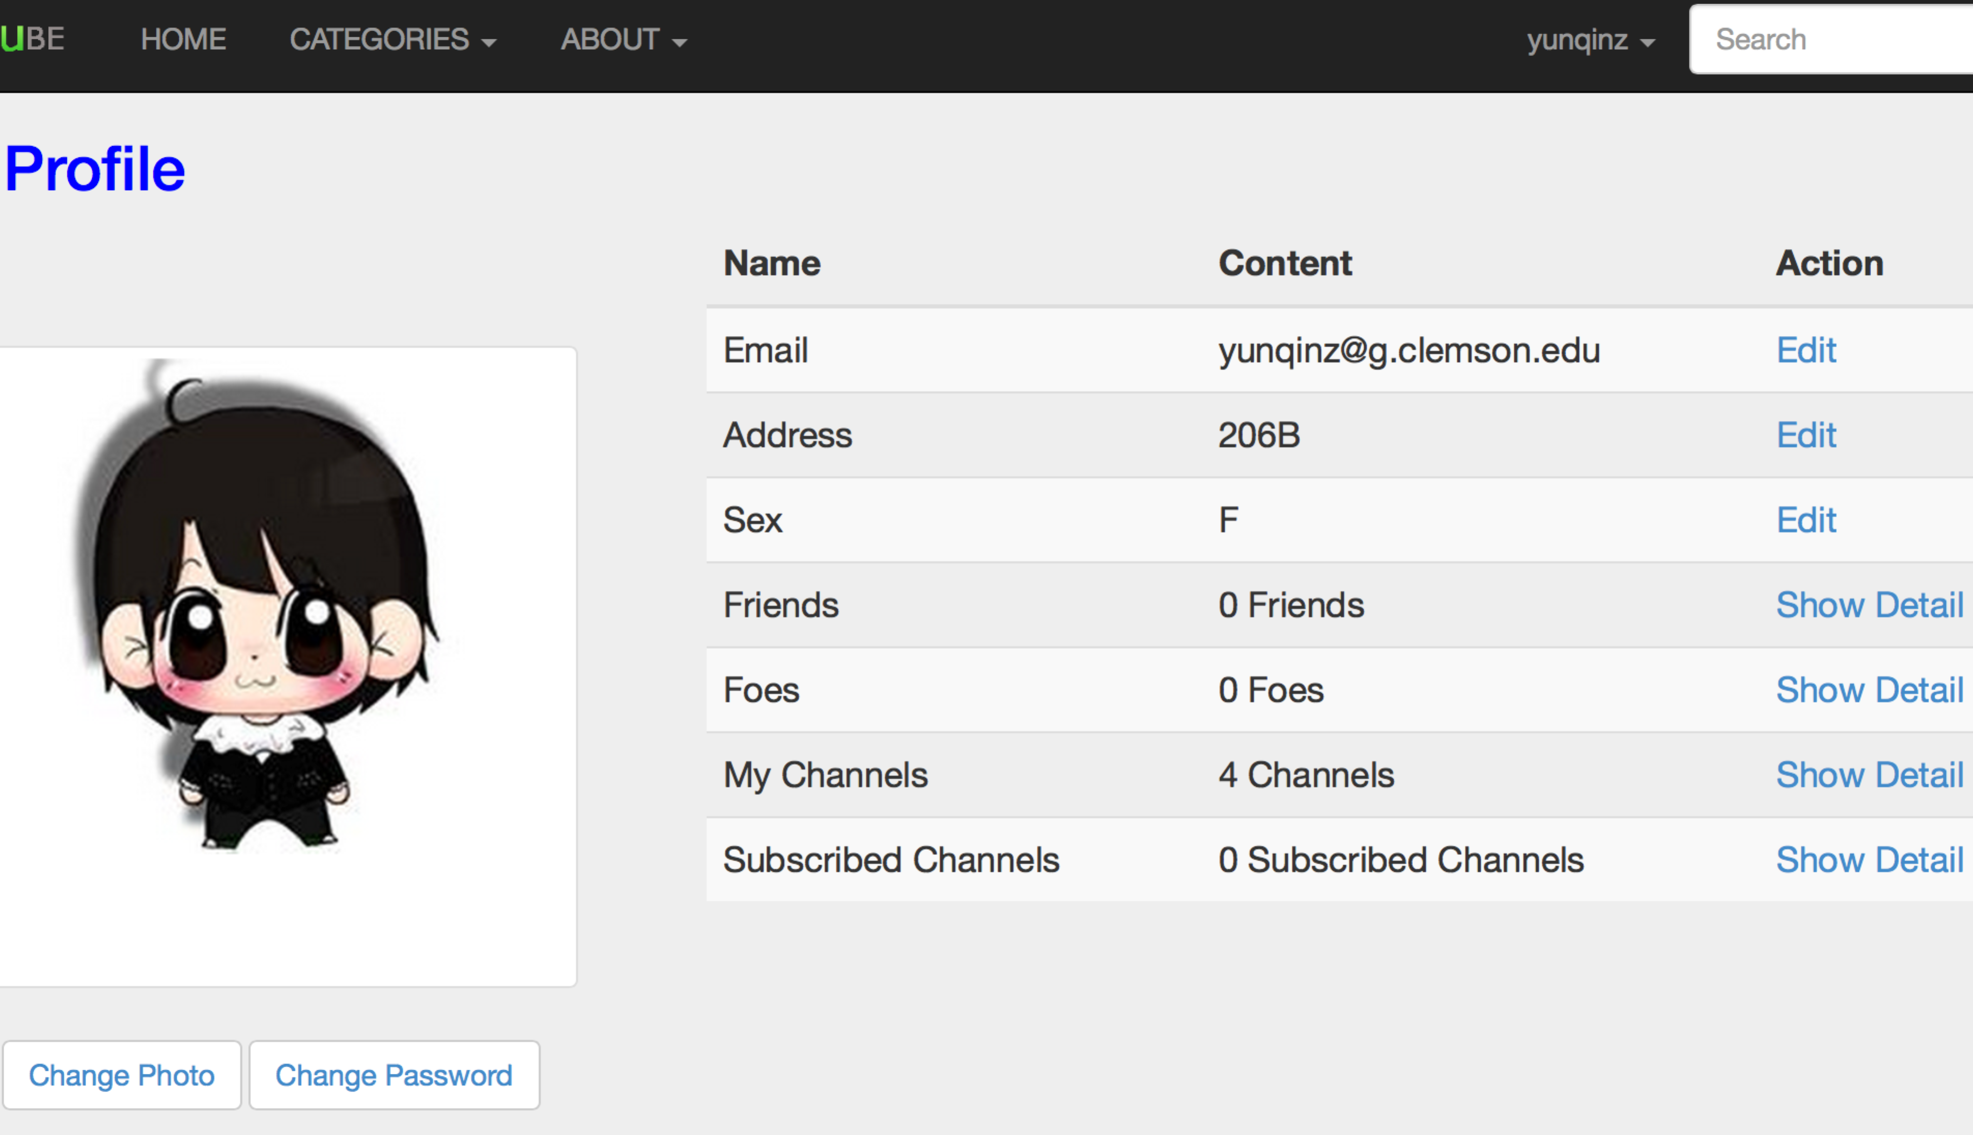

## 1.4 Contact

Contact is showed on the list called ’All Friends’.

## 1.5 Friend/foe/User Blocking

Click ‘Make friend’ button,send the application to the friend,and wait for the response.If the opposite side verify and you are friends with his/her.In this following webpage,you can set block and make foe with others.If A sets B as a foe,then B cannot see A’s media.However A can see all of B public to it.

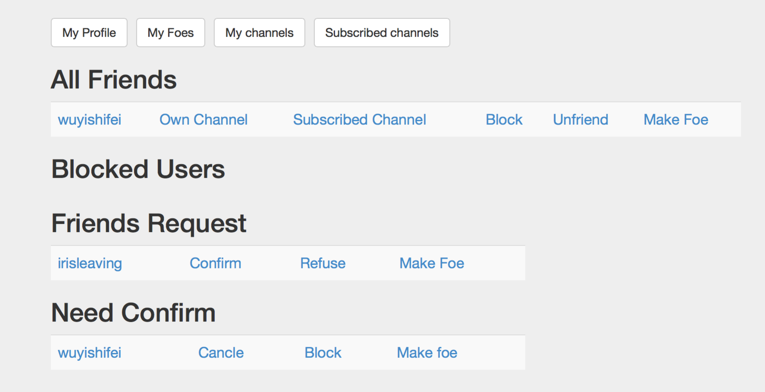

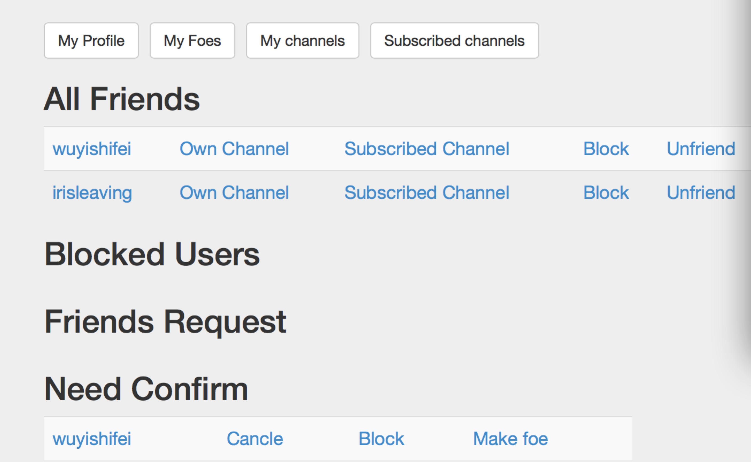

After confirmation, one friend is added to ‘All Friends’list.It shows all friend’s name.

# 2. Data Sharing

## 2.1 Upload

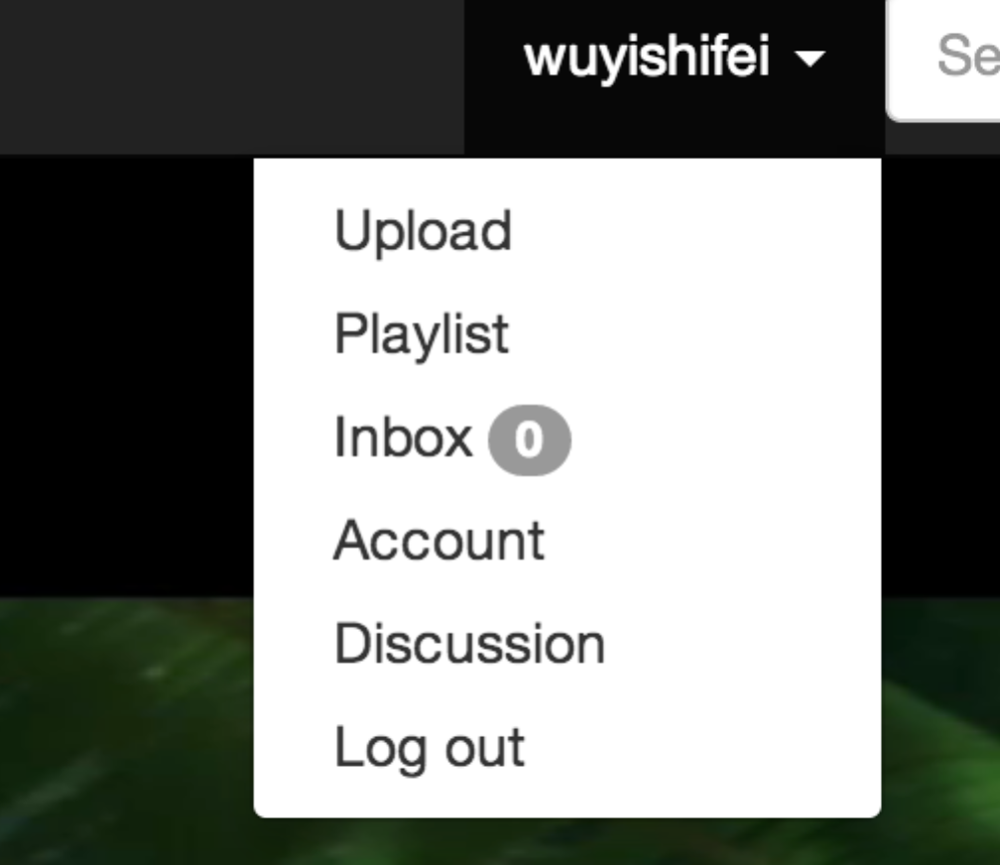

Click the ‘upload’ button, the webpage displays like the figure . You can upload four types of media. Click ‘quick upload’ button.

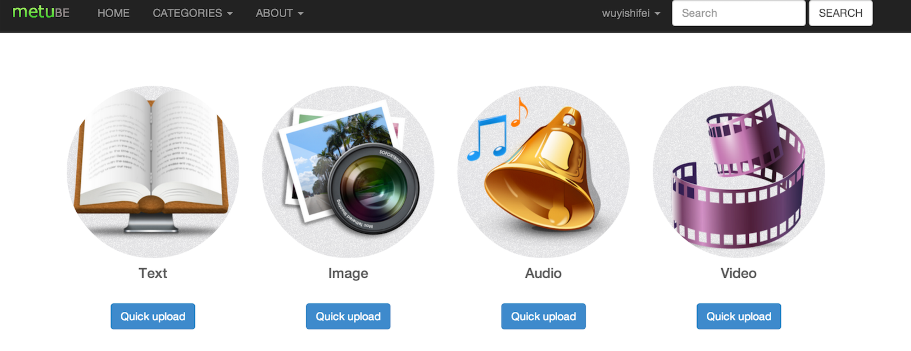

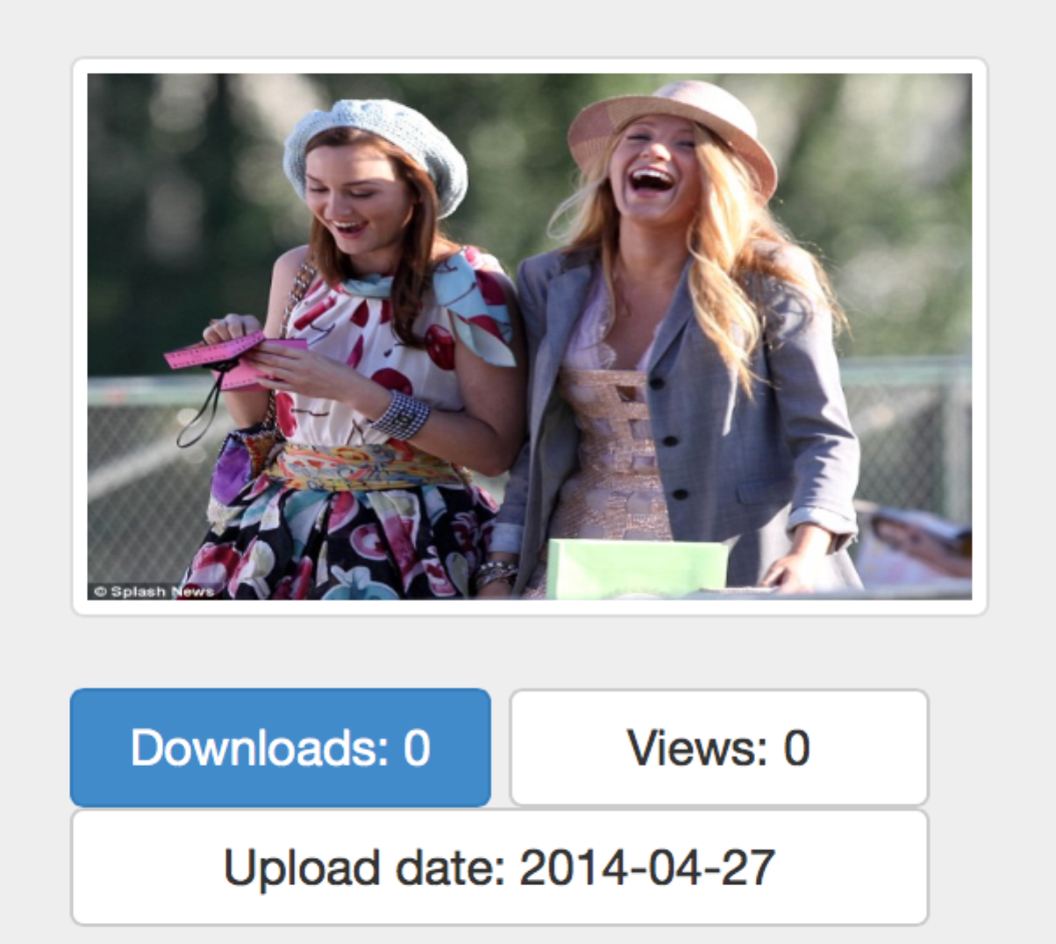

After finishing upload ,the upload details will be displayed.

## 2.2 Meta data input

Enter the upload page to fill the information about the media you want to upload.

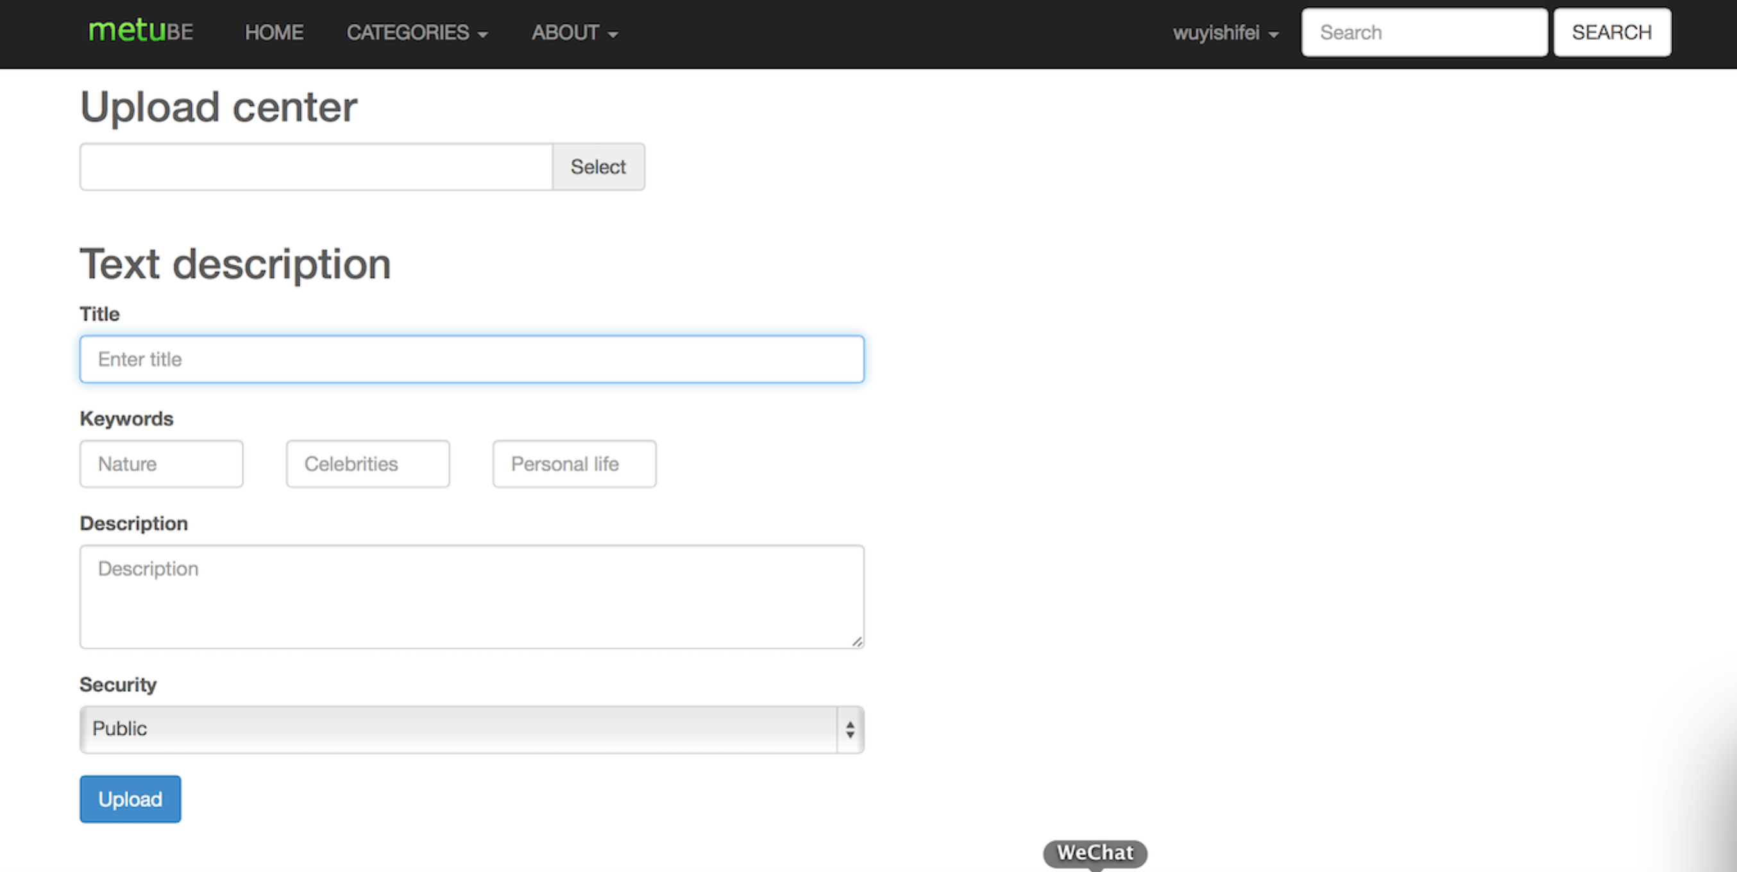

## 2.3 Download/View

Click the media name, you can view the media. Put the mouse at the bottom of the page, the ‘download’ button is displayed. Click it, a dialog window is displayed. You can choose where the media to be downloaded.

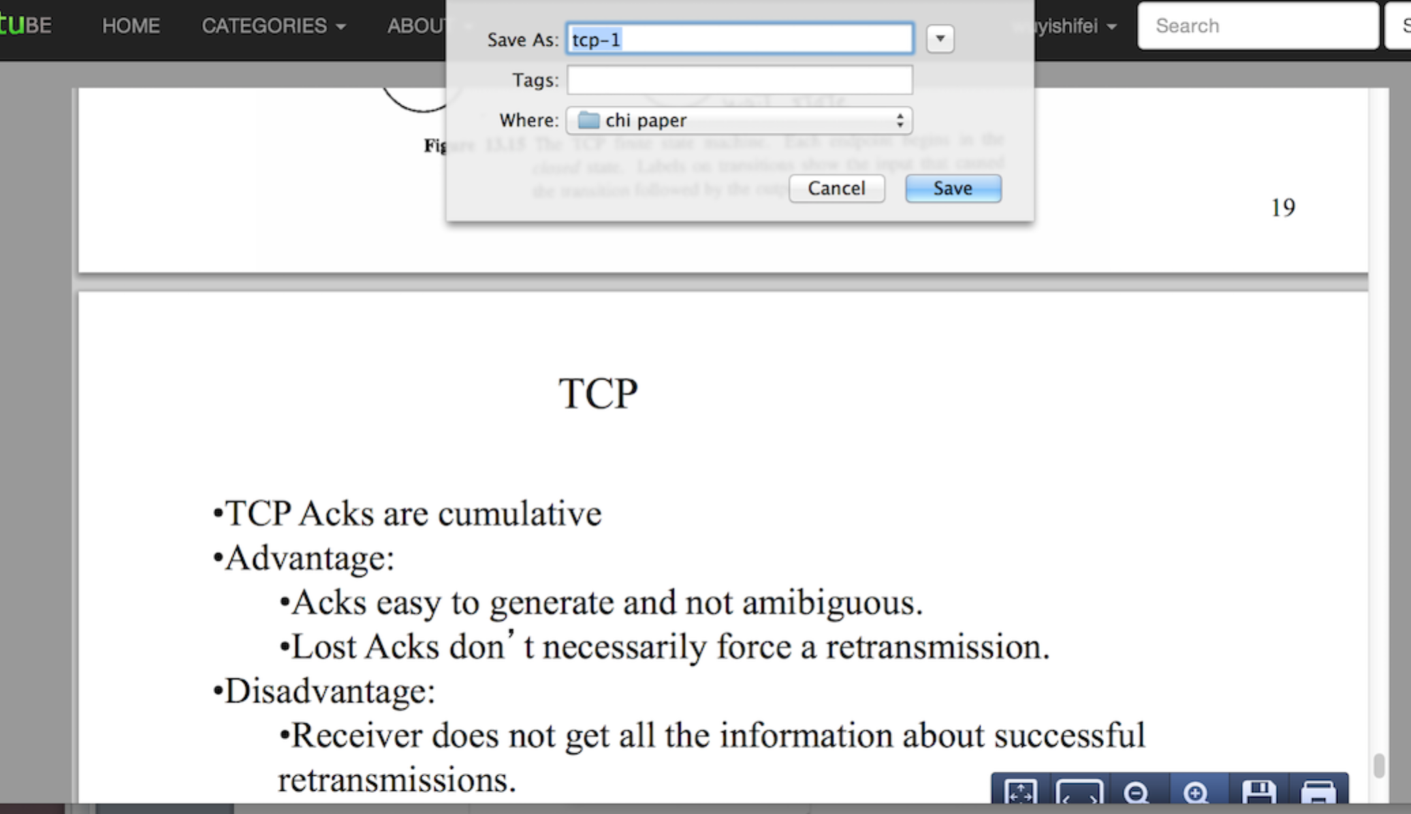

## 2.4 Media sharing/blocking

Entering the user personal page, ’Block’ button sets the media privilege. There are two types of block .One is block all the privilege, in other words, the media cannot be view and downloaded.The other type is blocking media privilege by catogry. It means block all text/image/audio/video media type by type. To the blocked thing, user set it, can unblock it.What’s more user can change the block type.

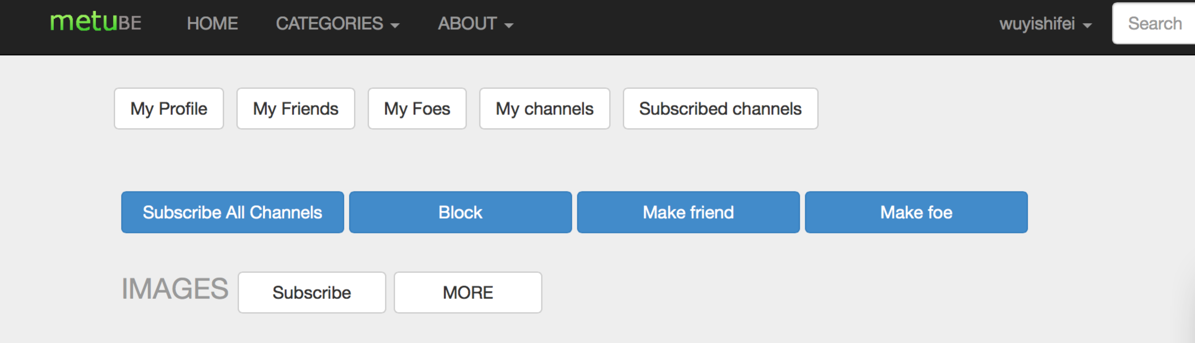

# 3. Media Organization

## 3.1 Browse by category

In homepage,the navigation bar gives the function to view media by catogroy.



## 3.2 Channel

Entering personal homepage, you can check your own channel. Channel is organized by media types. When click the specific type, detailed information will be displayed.When checking channel other user made, there is one more ‘unsubscribe’ button than channel yourself.

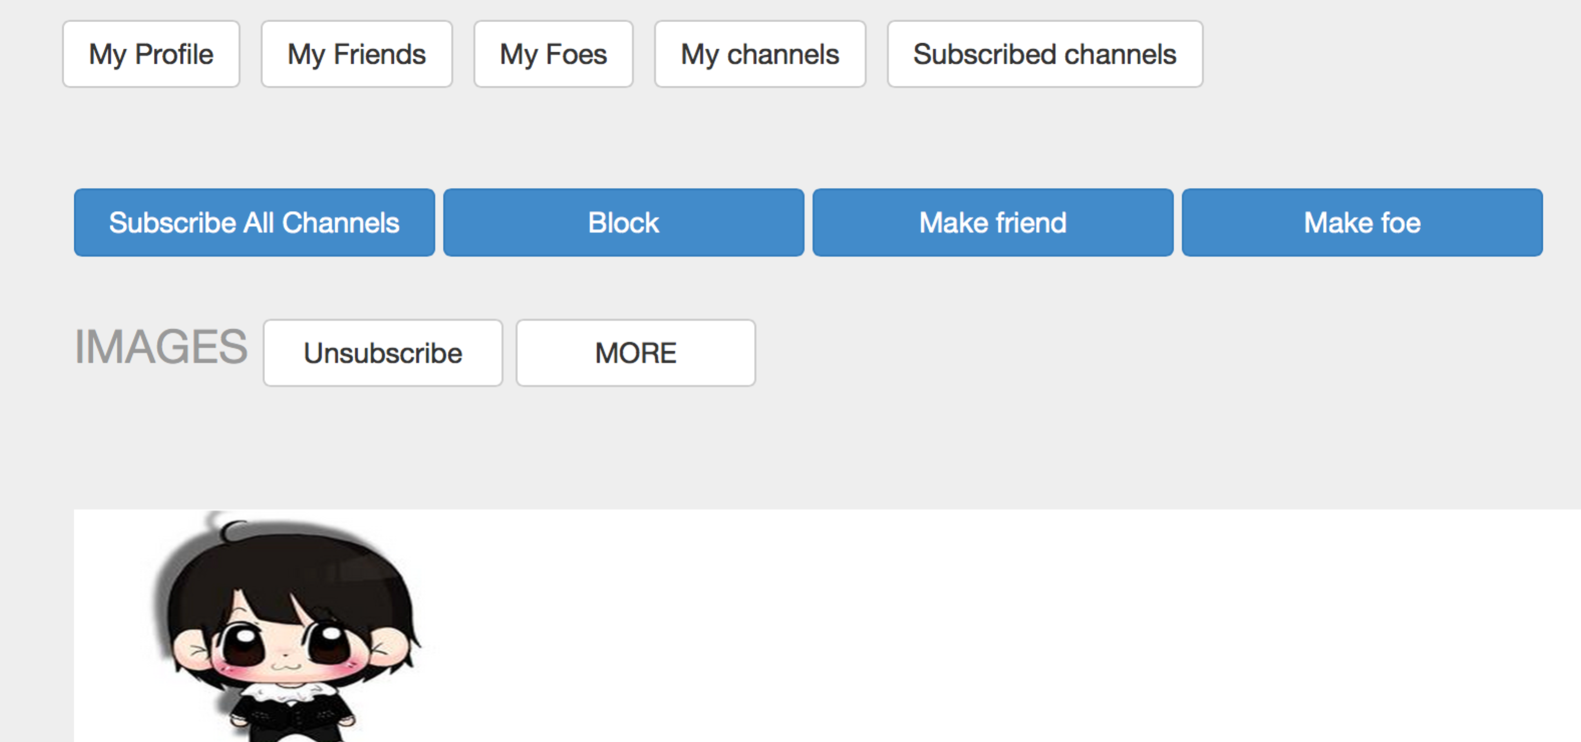

## 3.3 Playlists

.

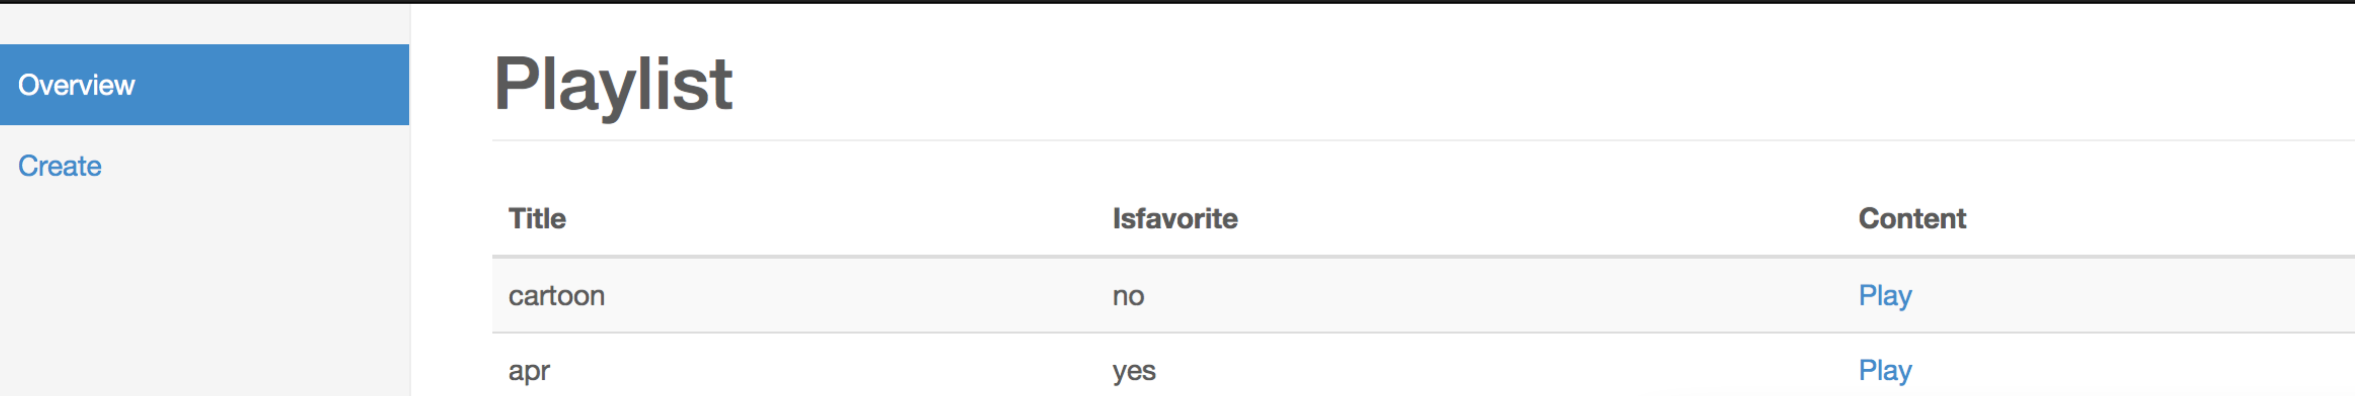

Click the ‘create’button, fill in some basic information, a new playlist is created. All of names of list are displayed here, click ‘play’ button to see the details of playlist

## 3.4 Favorite Lists

When create a new playlist.You have to choose it as a favorite or not. If you say yes, then it will be set as a favorite list.

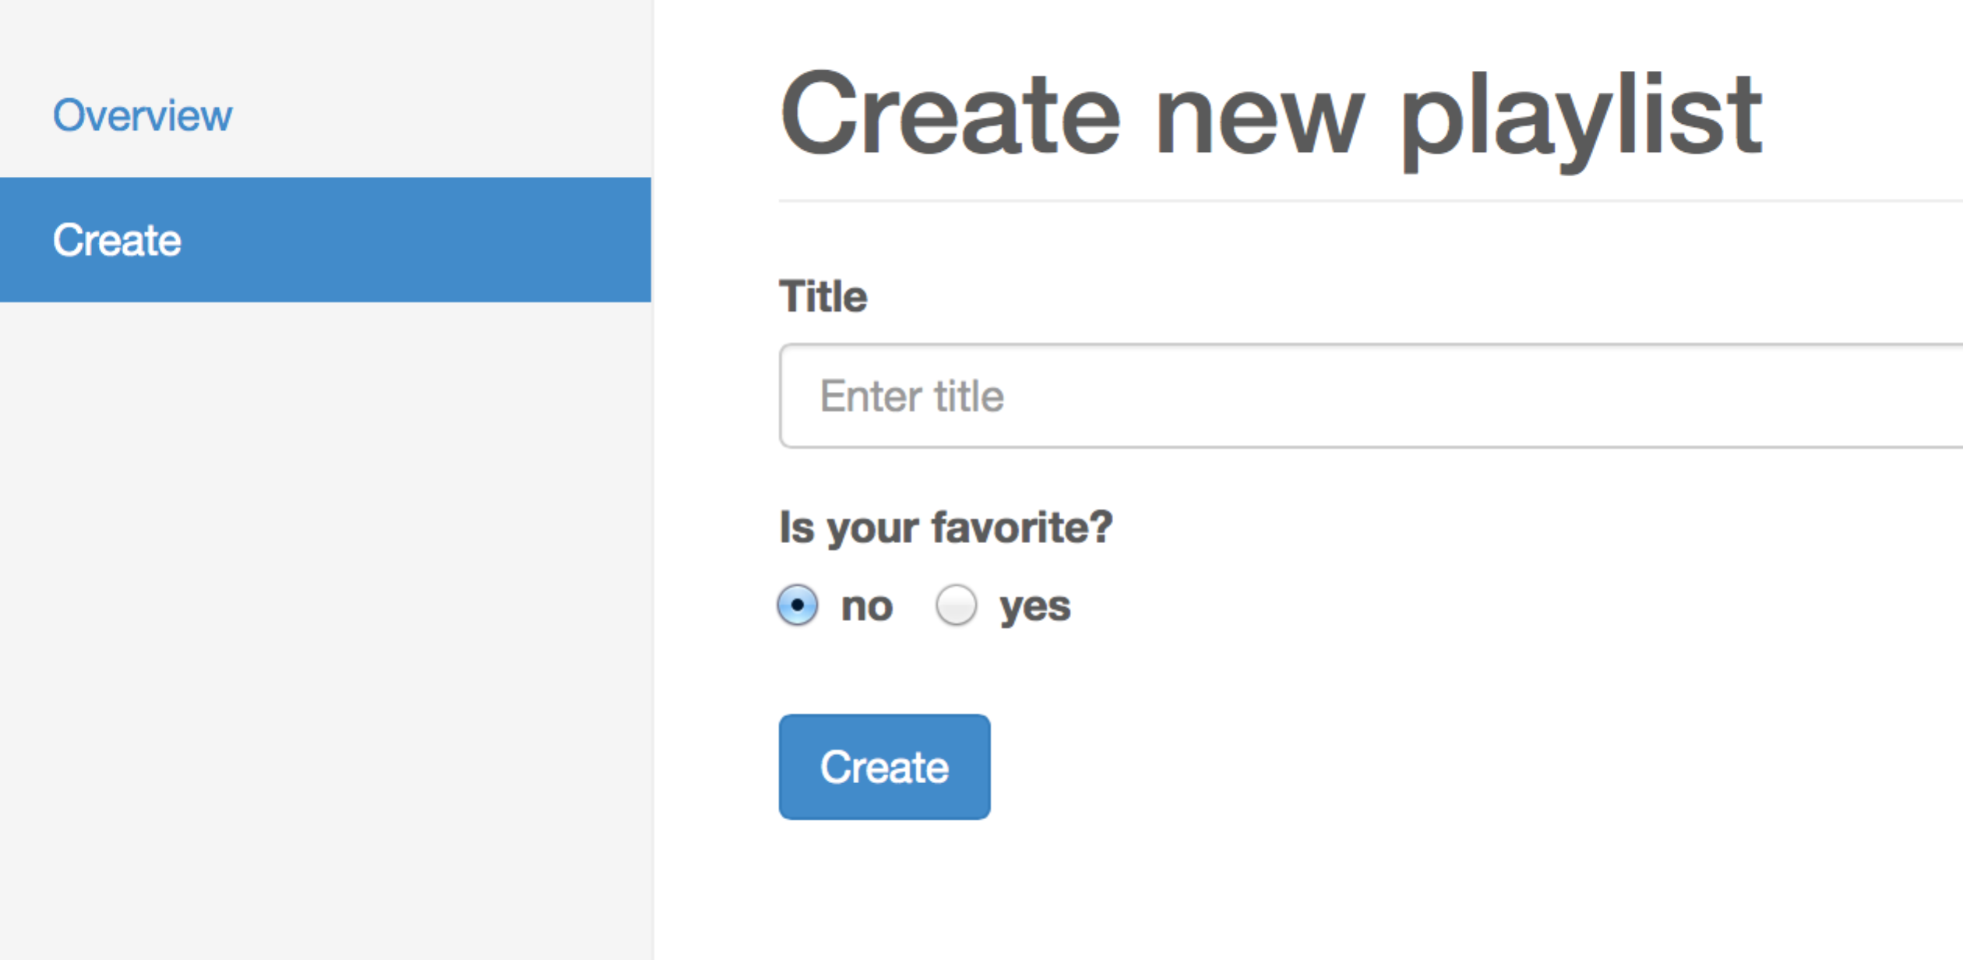

## 3.5 Most viewed

The homepage is displayed in the rule of top 15 most viewed.

## 3.6 Most recently uploaded

In the personal page,somemost-recently uploaded media display by category.Button‘most view medias’ under the ‘about’ button on the navigation bar.



# 4. User interaction

## 4.1Messaging

User can communicate with their friends through messages.

Click ‘Inbox’ button go to the message webpage, Click ‘Compose’ button, go to webpage below comes up. Fill the receiver’s email and subject and text. Click ‘Send’, the receiver will receive your message.

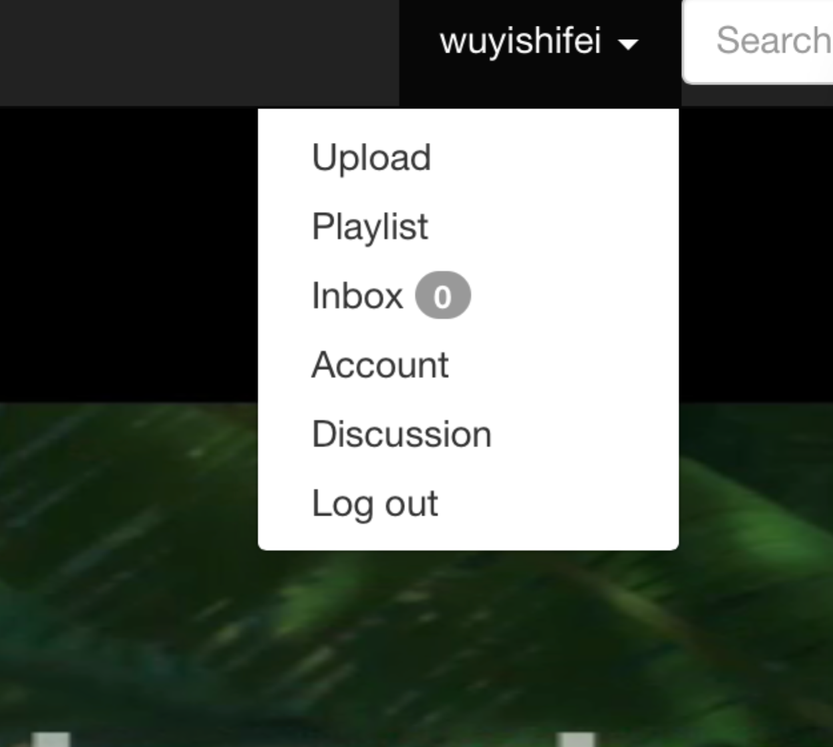

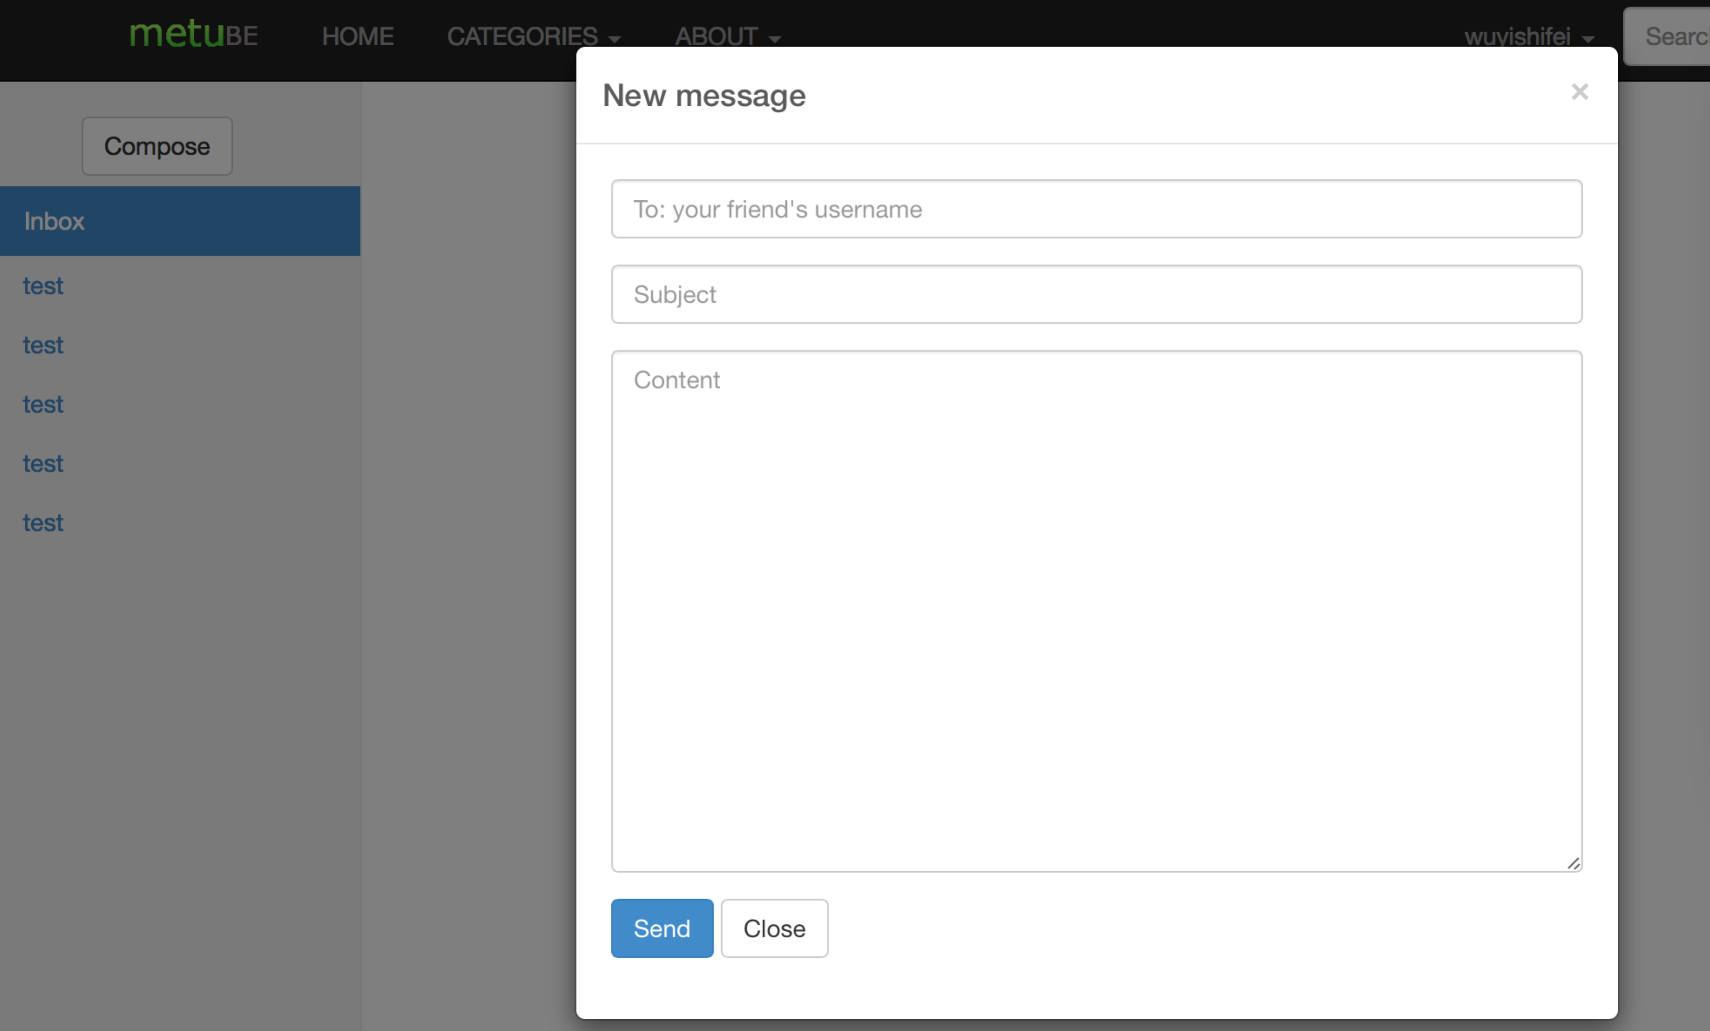

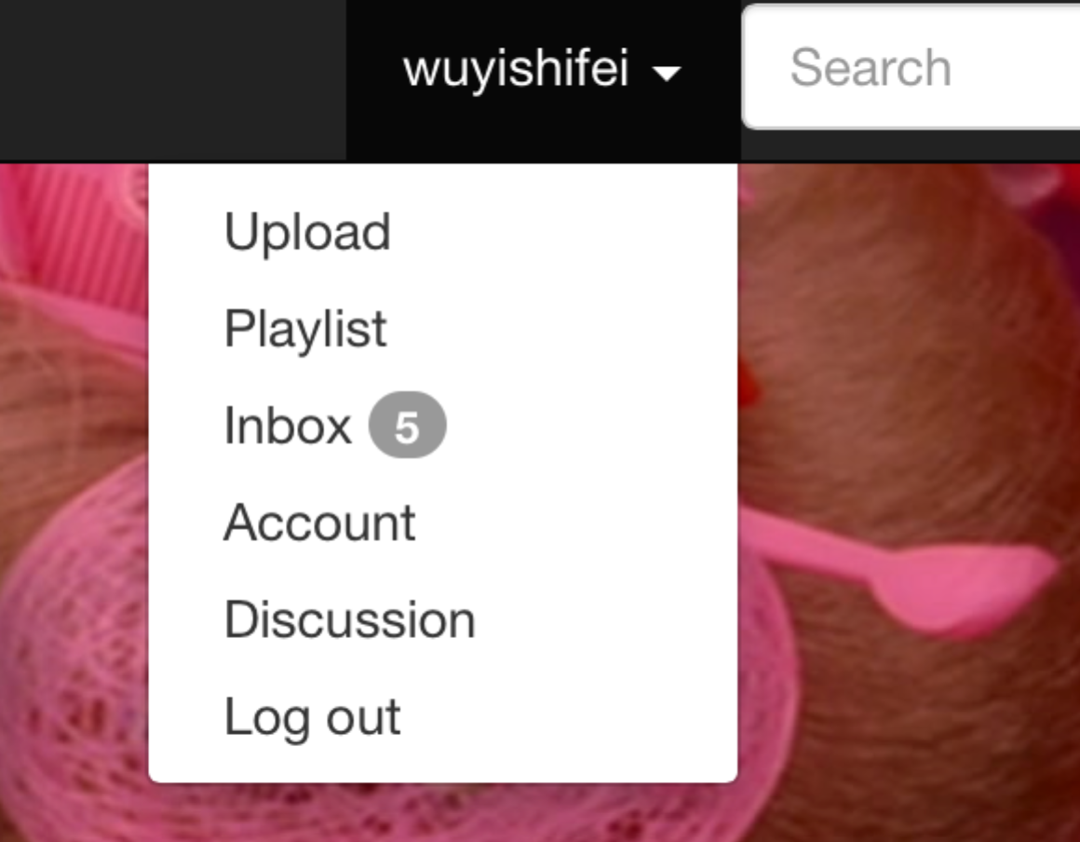

## 4.2 Commenting

Click one specific media, you can see comment column at the bottom of the media.

On this page, you can submit your comment and reply other’s comment. Your reply can

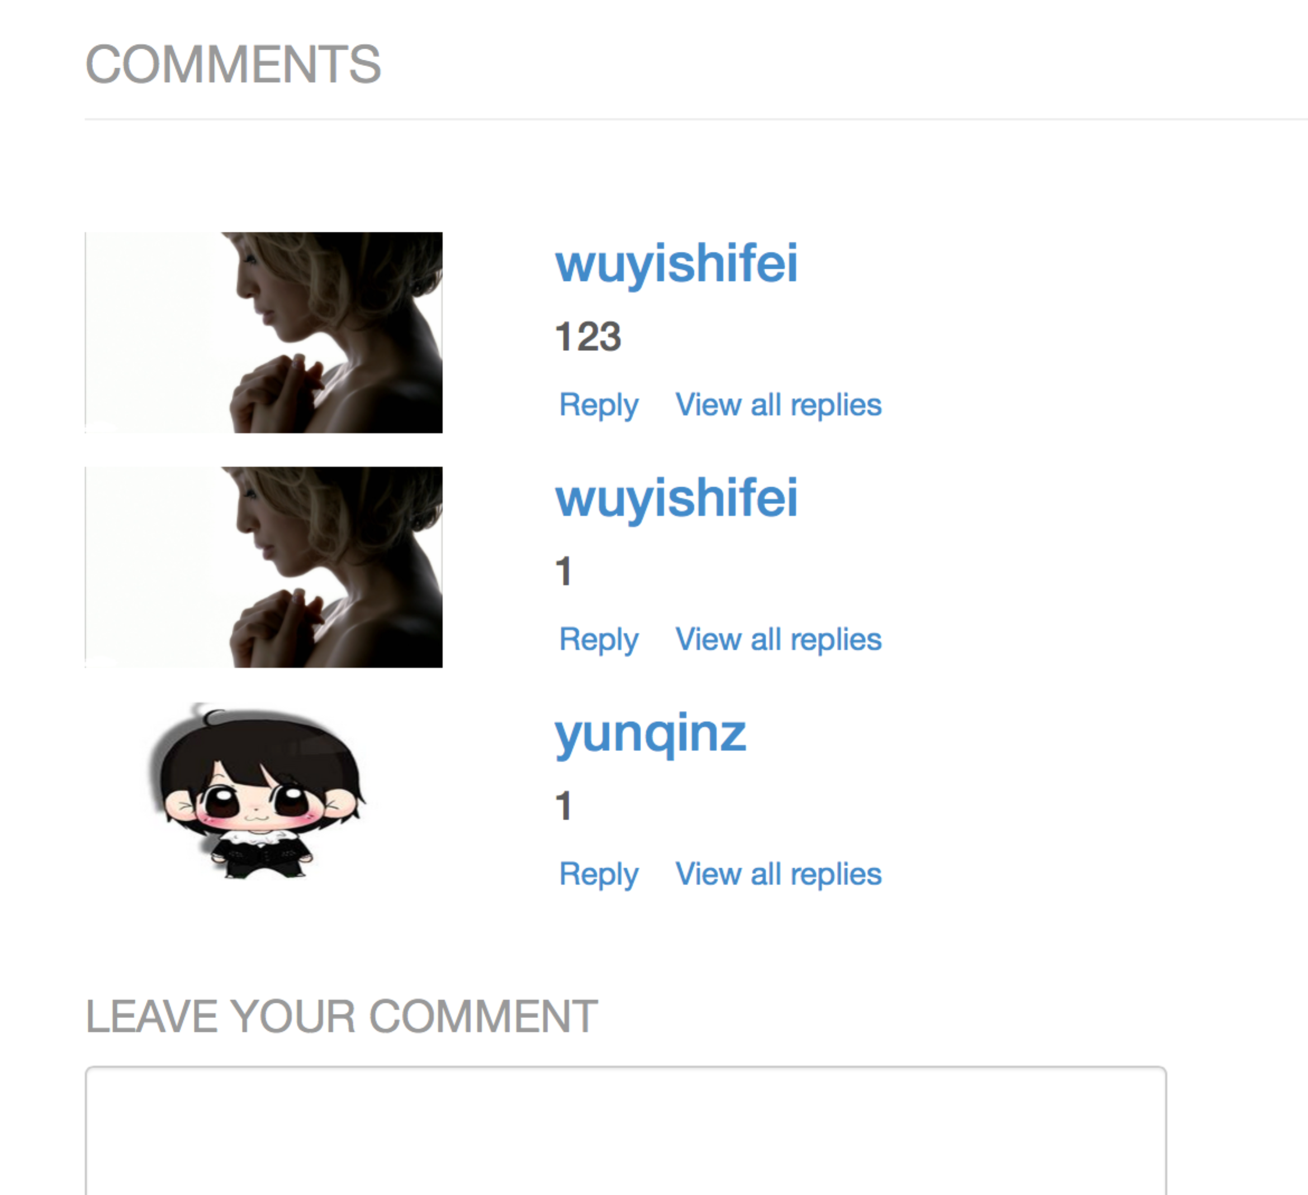

## 4.3 Media rating

Click one specific media ,you can see five stars at the bottom of the media. You click the stars to rate this media.



## 4.4 Group discussion

Click ‘Discussion’ button, you will see an webpage, in which you can check the established group, and create a new group. Click ‘see more’ button, a new discussion and a new discussion group can be created.

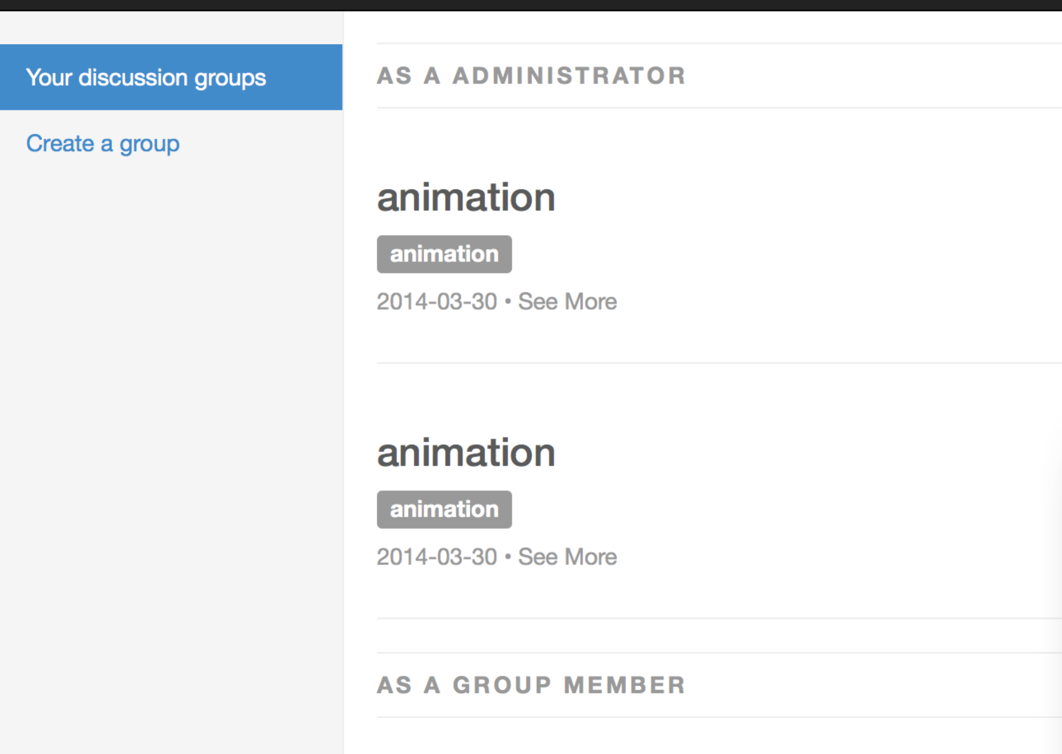

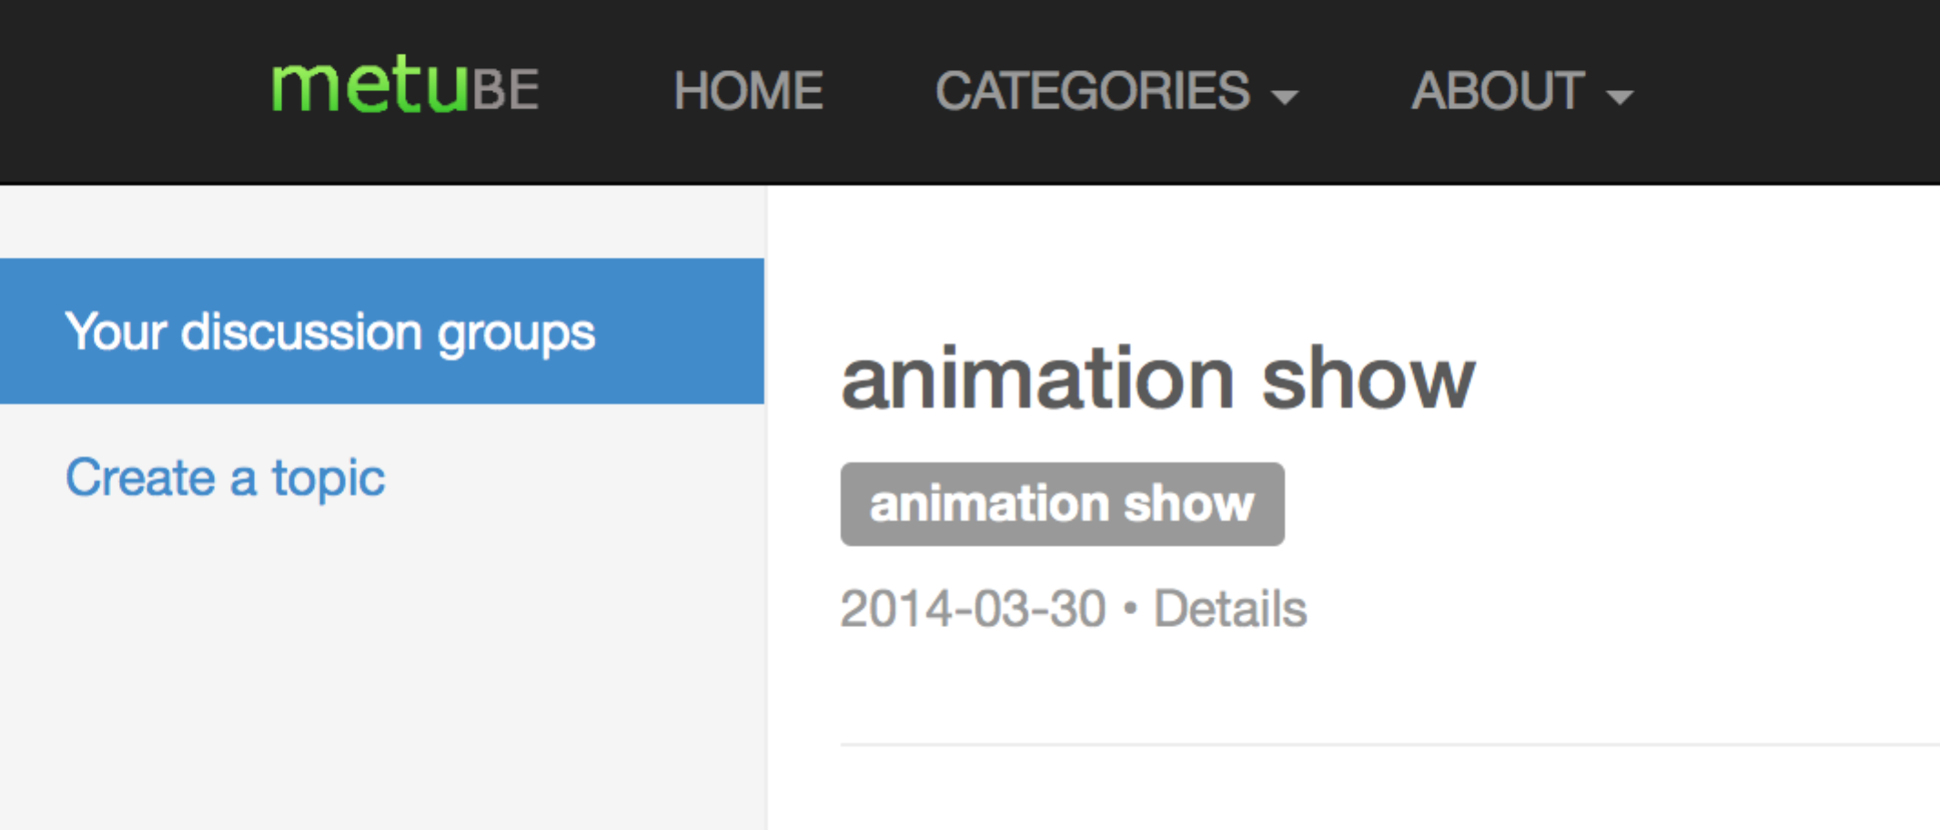

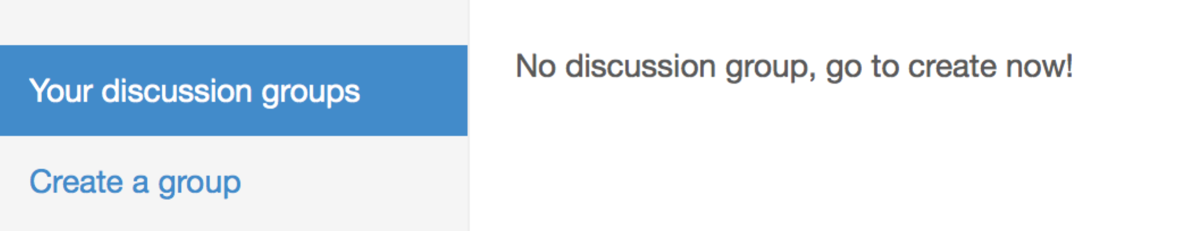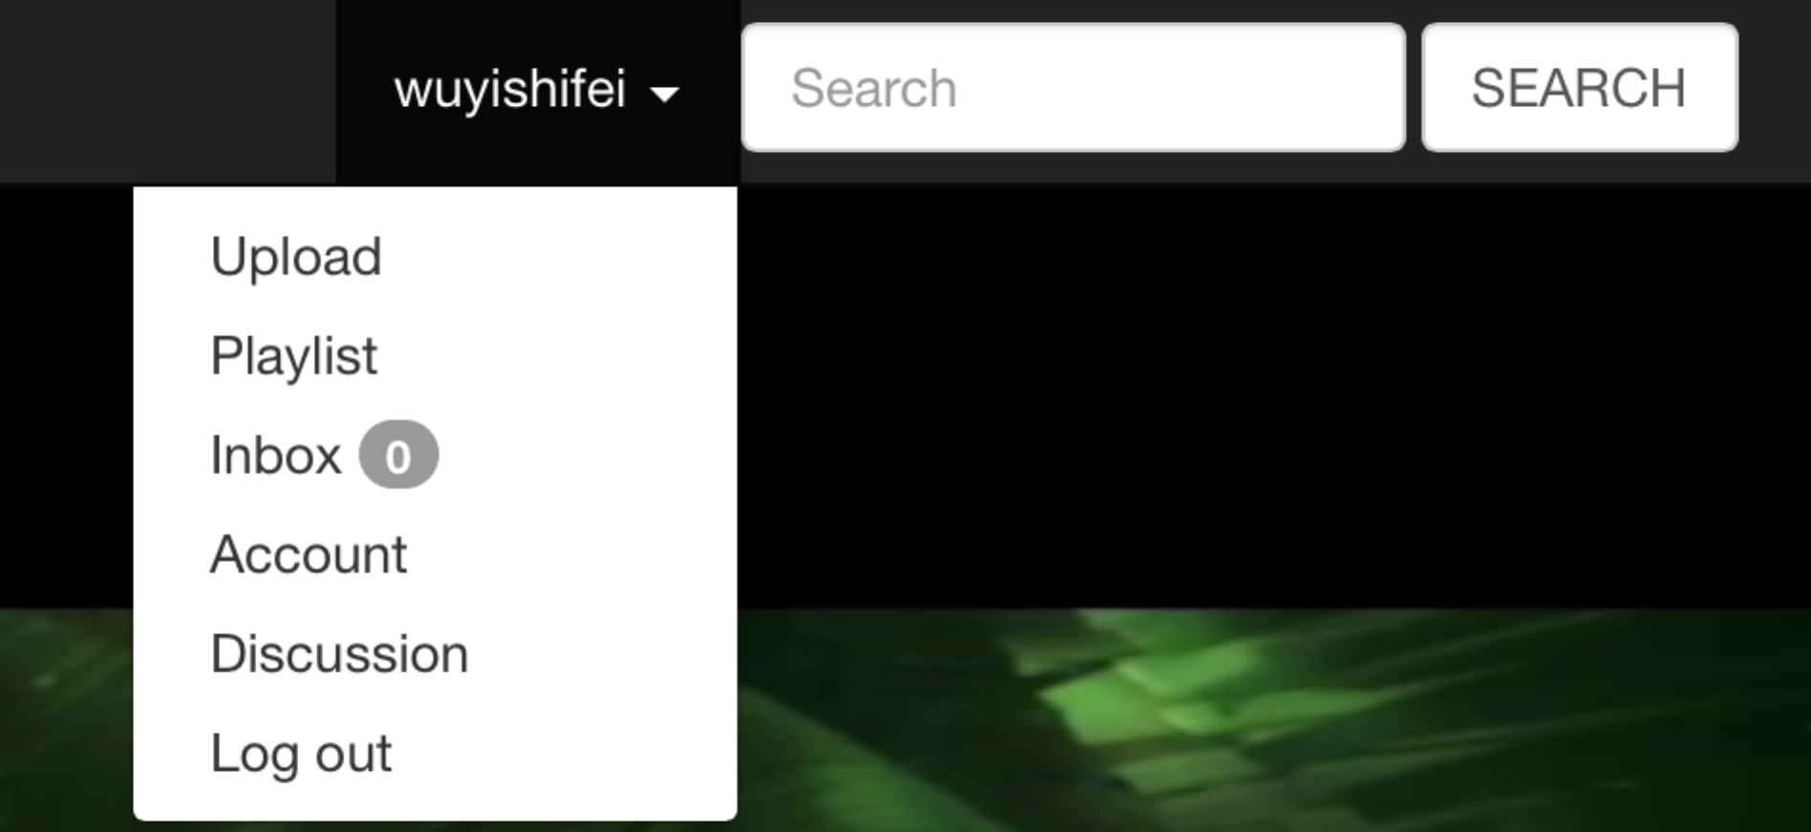

# 5.Search

## 5.1Keywords-based search

The default search is based on the keywords you filled up when you upload the media.

For example:

Input keyword ’food’ to search



searching results list as follows:

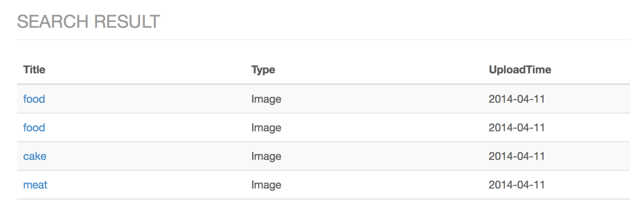

## 5.2 Word cloud

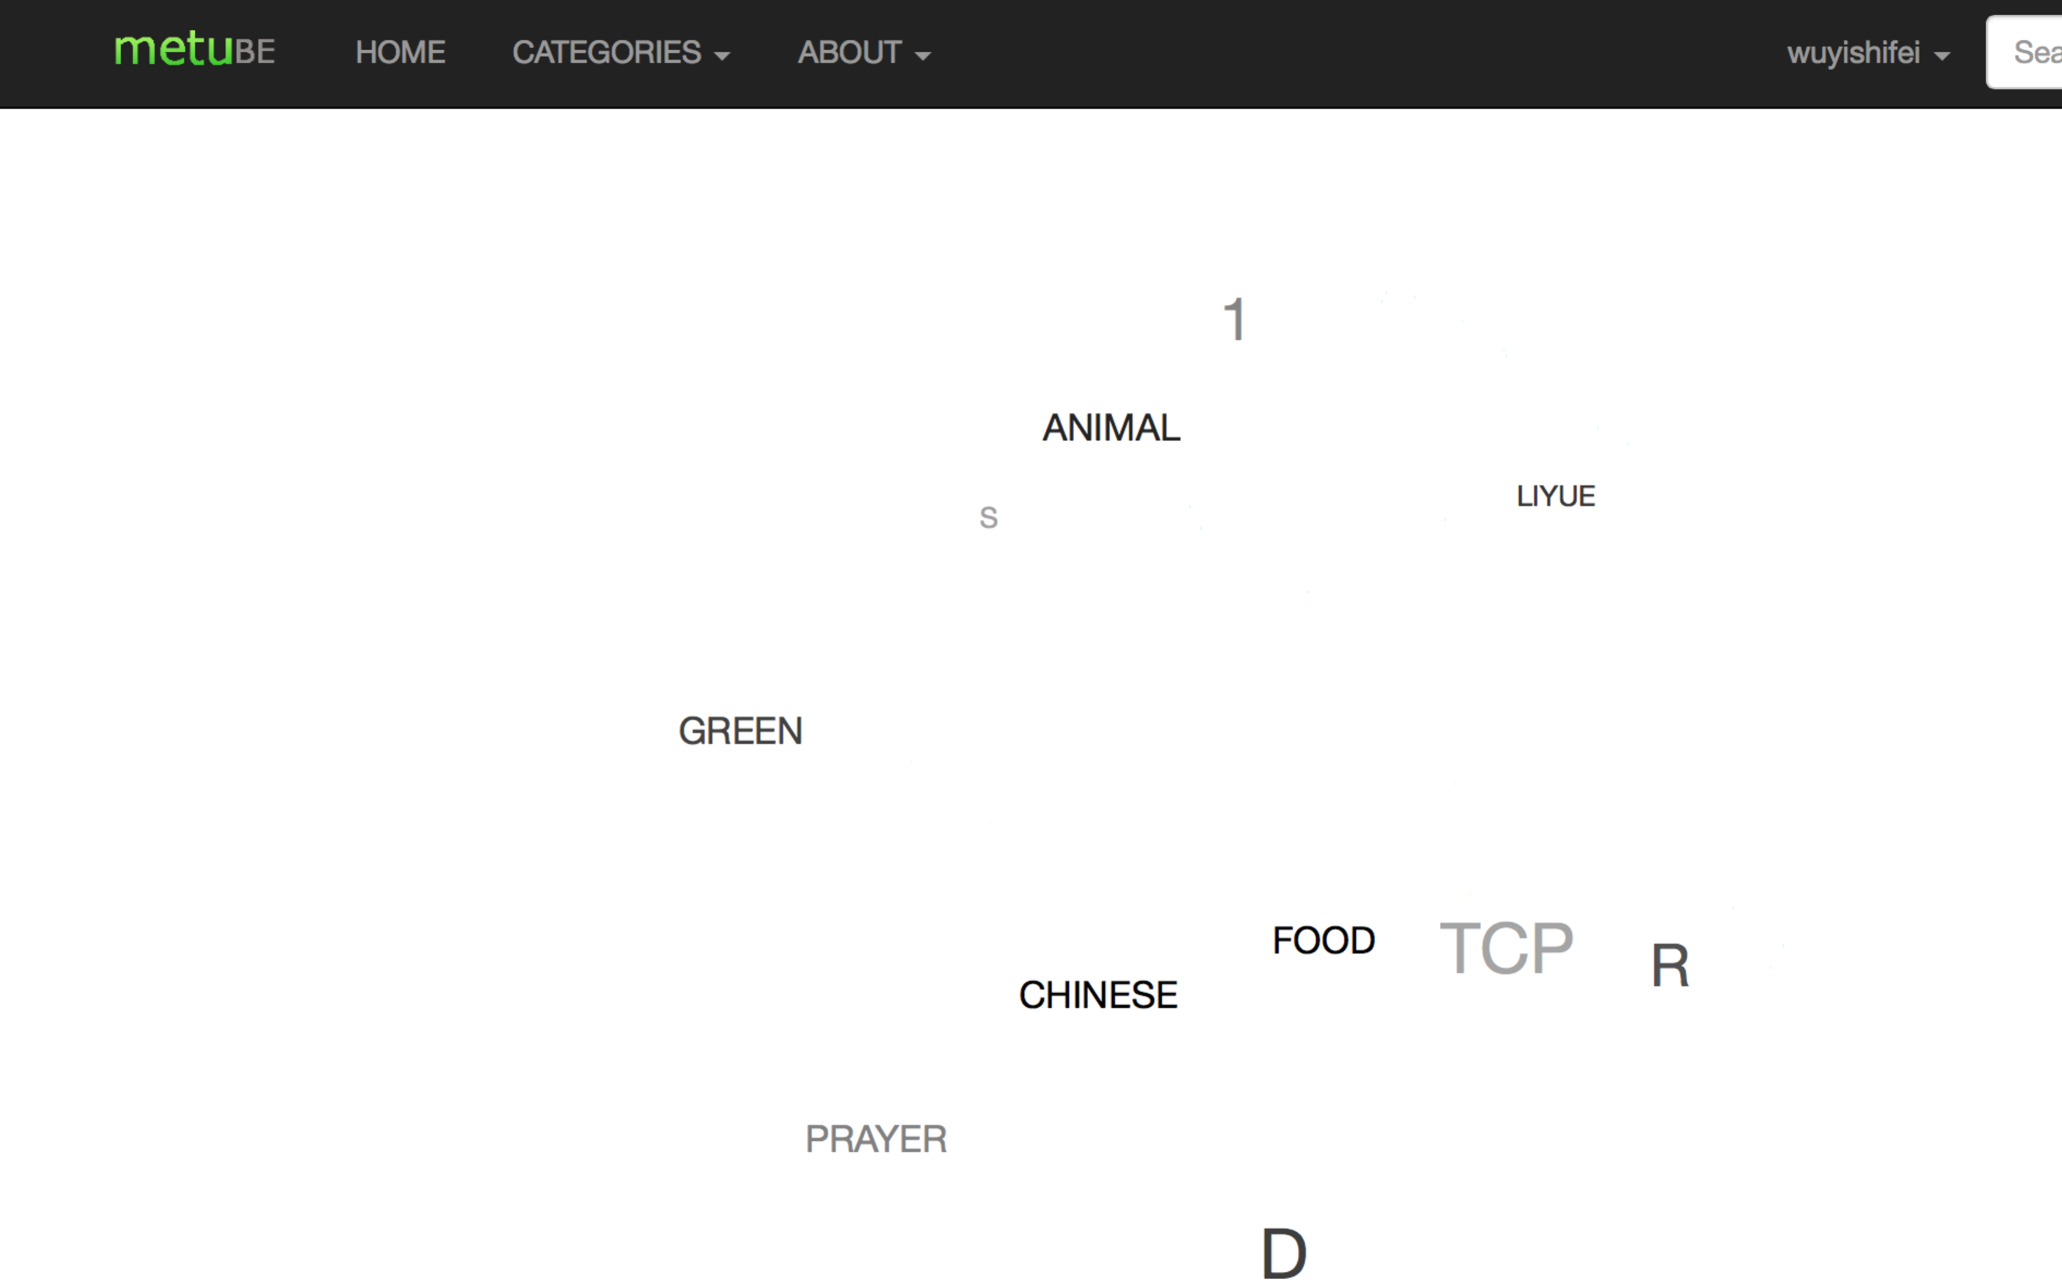

Click button ‘search’, you will see the word cloud.The word rotates with your mouse moves on screen.

The most recently researched words are displayed on this cloud.You click one word,the search result will be displayed.

## 5.3 Media recommendation

In homepage, there is a column called recommendation. It recommends user some media through your play record.

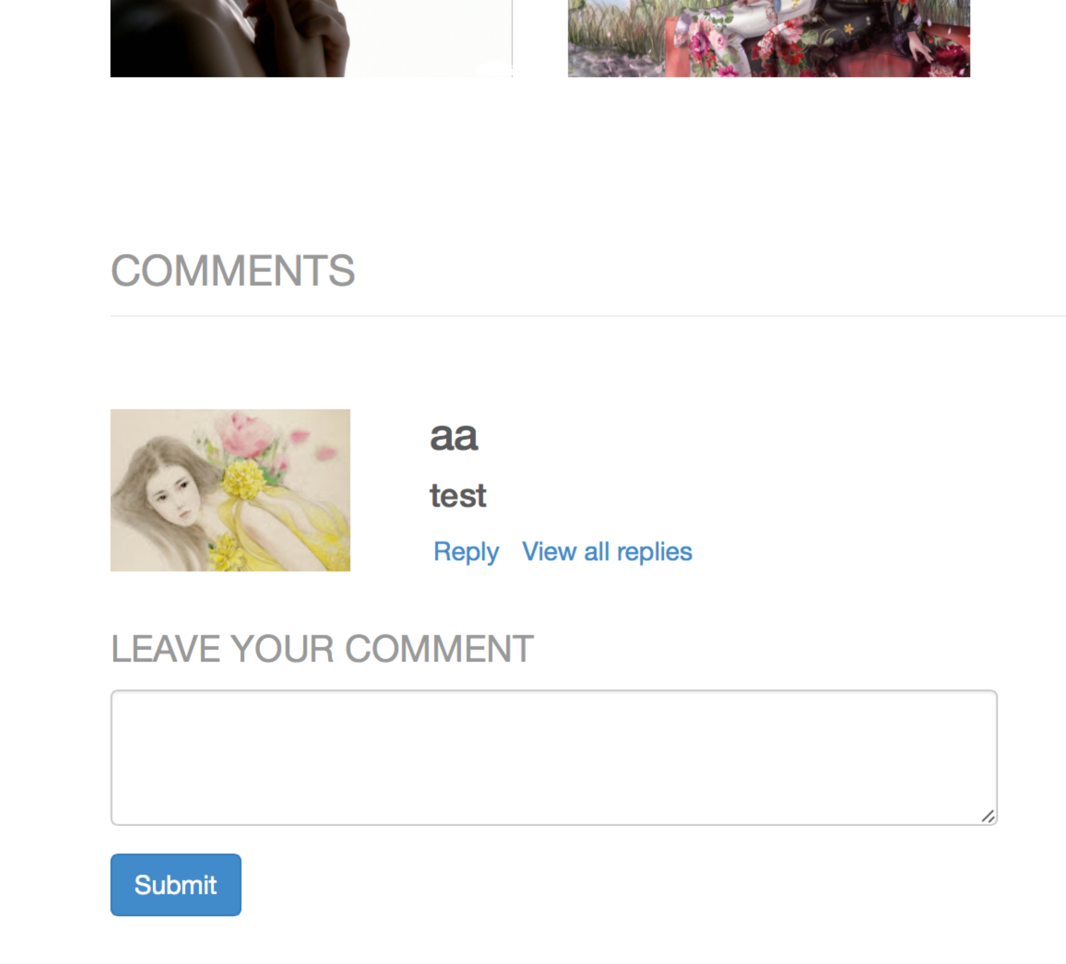

## 5.4 Feature-based media search

The ‘ABOUT’ button on navigation bar show the two fetures.One is feature-based media research. Click this item, you will see the webpage below.

If you input keywod’food’,searching result listed as follows:



    
    
    